

LAB FILE
SUBJECT – FINANCIAL MODELLING USING SPREADSHEET BACHELOR OF COMMERCE
SUBJECT CODE: BCOM 312

Under the Guidance of: Submitted by:
Ms. Vandana Awasthi NAME: SAHIL GARG
FACULTY DTC BCOM- 6TH SEMESTER
ENROLLMENT NO.: 00718088822

BATCH 2022-25
DELHI TECHNICAL CAMPUS, GREATER NOIDA AFFLIATED TO GGSIPU DWARKA

ACKNOWLEDGEMENT

I would like to express my special thanks of gratitude to my teacher Vandana Awasthi, who gave this opportunity to do this project on ‘FINANCIAL MODELLING USING SPREADSHEET. Who also helped me to completing my project. I came to know about so many new things I am really thankful to them.
Secondly I would like to thank my parents and friends who help me a lot in finalizing this project within the time limit frame.
I am overwhelmed in all humbleness and gratefulness to acknowledge my depth to all those who have helped me to put these ideas, well above the level of simplicity and into something concrete.

NAME: Sahil Garg

UNDERTAKING BY THE STUDENT

I SAHIL GARG, 00718088822 Student of BCOM-VI semester batch 2022-25 of the DELHI TECHNICAL CAMPUS, Greater Noida hereby declare that lab file titled “FINANCIAL MODELLING USING SPREADSHEET” is an original work and the same has not been submitted to any other University or Institution for the award of any degree, diploma/certificate or published any time before.

Date: Signature of Student

INDEX

S.NO. | TOPICS | PAGE NO.
1. | V-LOOKUP FUNCTION | 5-9
2. | H-LOOKUP FUNCTION | 10-13
3. | PRACTICE QUESTIONS | 14-16
4. | INDEX MATCHING FUNCTION | 17-18
5. | NET PRESENT VALUE (NPV) | 19-21
6. | IF LOOKUP FUNCTION | 22-24
7. | IRR FUNCTION | 25
8. | XIRR FUNCTION | 26-27
9. | MIRR FUNCTION | 28
10. | WACC FUNCTION | 29-31
11. | CAPITAL ASSET PRICING MODEL (CAPM) | 32-33
12. | BETA FUNCTION | 34-35
13. | CONCLUSION | 36

VLOOKUP FUNCTION
VLOOKUP stands for ‘Vertical Lookup’. It is a function that makes Excel search for a certain value in a column (the so called ‘table array’), in order to return a value from a different column in the same row. This article will teach you how to use the VLOOKUP function.
VLOOKUP function exists of 4 components:
- The value you want to look up;
- The range in which you want to find the value and the return value;
- The number of the column within your defined range, that contains the return value;
- 0 or FALSE for an exact match with the value your are looking for; 1 or TRUE for an approximate match.

VLOOKUP Formula
=VLOOKUP(lookup_value, table_array, col_index_num, [range_lookup])

To translate this to simple English, the formula is saying, “Look for this piece of information, in the following area, and give me some corresponding data from another column”.
The VLOOKUP function uses the following arguments:
- Lookup_value (required argument) – Lookup_value specifies the value that we want to look up in the first column of a table. For example, if the data is in columns A through C, then the Lookup_value must be in column A.
- Table_array (required argument) – The table array is the data array that is to be searched. The VLOOKUP function searches for the Lookup_value in the left- most column of this array. You can use a named range or a table, and you can use names in the argument instead of cell references.
- Col_index_num (required argument) – This is an integer, specifying the column number of the supplied table_array, that you want to return a value.

- Range_lookup (optional argument) – This defines what this function should return in the event that it does not find an exact match to the lookup_value. The argument can be set to TRUE or FALSE, which means:
- TRUE – Approximate match, that is, if an exact match is not found, use the closest match to the lookup_value. By selecting TRUE, VLOOKUP assumes the first column in the table is sorted either numerically or alphabetically, and will then search for the closest value.
- FALSE – Exact match, that is, if an exact match not found, then it will return an error.
- You may also type 1 for TRUE or 0 for FALSE. If neither TRUE or FALSE is selected, Excel defaults to TRUE.

How to use VLOOKUP in Excel
Step 1: Organize the data
The first step to effectively using the VLOOKUP function is to make sure your data is well organized and suitable for using the function.
VLOOKUP works in a left-to-right order, so you need to ensure that the information you want to look up is to the left of the corresponding data you want to extract.
Step 2: Tell the function what to lookup
In this step, we tell Excel what to look for. We start by typing the formula “=VLOOKUP(“ and then select the cell that contains the information we want to lookup.
Step 3: Tell the function where to look
In this step, we select the table where the data is located, and tell Excel to search in the left-most column for the information we selected in the previous step.
Step 4: Tell Excel what column to output the data from
In this step, we need to tell Excel which column contains the data that we want to have as an output from the VLOOKUP. To do this, Excel needs a number that

Step 5: Exact or approximate match
This final step is to tell Excel if you’re looking for an exact or approximate match by entering “True” or “False” in the formula.

- On the student’s worksheet, create a VLOOKUP function that will return a student’s full name when a university ID is entered. Space has been provided at the top of the work sheet (A1:B2) for this Purpose.
ANSWER:
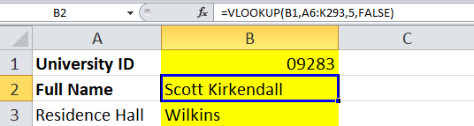
FORMULA - =VLOOKUP(B1,A6:K293,5,FALSE)
- Create a VLOOKUP function that will return the amount of fees a student owe based on their major. When the fees have been added, format column H as currency. HINT: you will need to work with both the students and fees worksheets.
ANSWER:
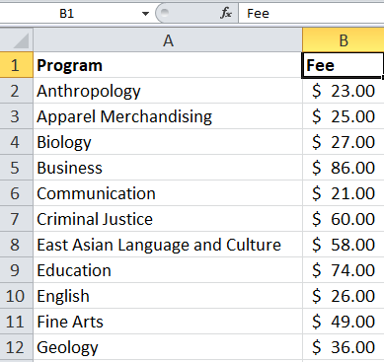

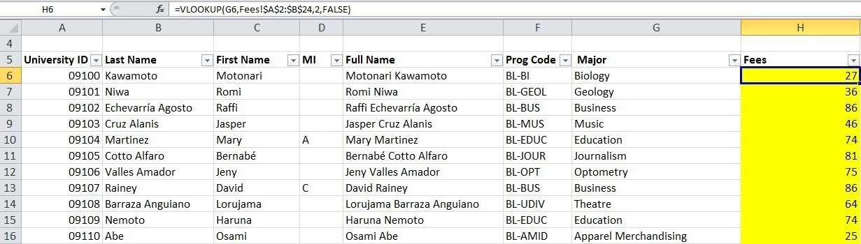
FORMULA: =VLOOKUP(G6,Fees!$A$2:$B$24,2,FALSE)
- Create a VLOOKUP function that will find a student’s residence hall. Add the Heading, Residence hall in cell A3.
ANSWER:
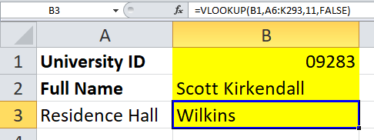
FORMULA: =VLOOKUP(B1,A6:K293,11,FALSE)
- On the Test Scores worksheet, create a VLOOKUP function to find the letter grade for each Student.
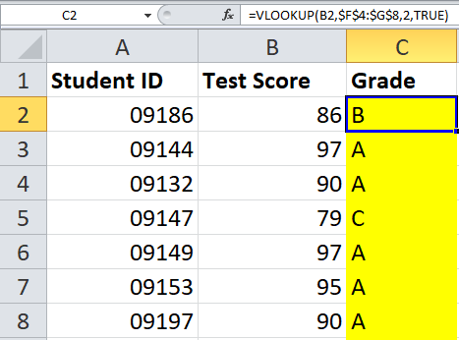
ANSWER:

FORMULA: =VLOOKUP(B2,$F$4:$G$8,2,TRUE)
- On the Students worksheet, create a VLOOPUP function to add the student’s grades to the student’s work sheet. Column L has been designated for this. Not all students in the students worksheet will have a grade. Use a filter to see only the students with grades.
ANSWER:
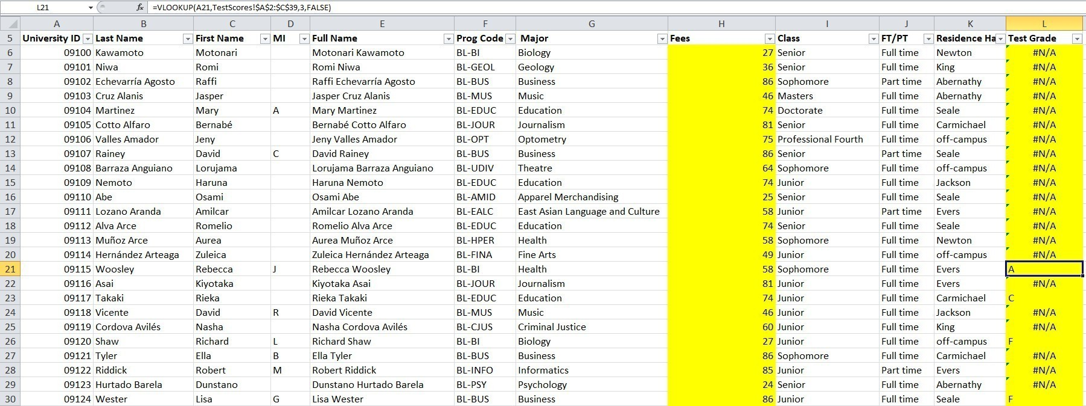
FORMULA: =VLOOKUP(A21,TestScores!$A$2:$C$39,3,FALSE)

HLOOKUP FUNCTION
HLOOKUP stands for Horizontal Lookup and can be used to retrieve information from a table by searching a row for the matching data and outputting from the
corresponding column. While VLOOKUP searches for the value in a column, HLOOKUP searches for the value in a row.
Formula
=HLOOKUP(value to look up, table area, row number)

Important points to keep in mind about HLOOKUP
  - It is a case-insensitive lookup. It will consider, for example, “TIM” and “tim” as the same.
  - The ‘Lookup_value’ should be the topmost row of the ‘table_array’ when we are using HLOOKUP. If we need to look somewhere else, then we must use another Excel formula.
  - HLOOKUP supports wildcard characters such as ‘*’ or ‘?’ in the ‘lookup_value’ argument (only if ‘lookup_value’ is text).
  - . #N/A error – It would be returned by HLOOKUP if ‘range_lookup’ is FALSE and the HLOOKUP function is unable to find the ‘lookup_value’ in the given range. We can embed the function in IFERROR and display our own message, for example: =IFERROR(HLOOKUP(A4, A1:I2, 2,
FALSE), “No value found”).
  - 5. If the ‘row_index_num’ < 1, HLOOKUP would return #VALUE! error. If ‘row_index_num’ > number of columns in ‘table_array’, then it would give #REF! error.
  - 6. Remember HLOOKUP function in Excel can return only one value. This would be the first value n that matches the lookup value. What if there are a few identical records in the table? In that scenario, it is advisable to remove them or create a Pivot table and group them. The array formula can then be used on the Pivot table to extract all duplicate values that are present in the lookup range.

Syntax
HLOOKUP(lookup_value, table_array, row_index_num, [range_lookup]) The HLOOKUP function syntax has the following arguments:
    - Lookup_value Required. The value to be found in the first row of the table. Lookup_value can be a value, a reference, or a text string.
    - Table_array Required. A table of information in which data is
looked up. Use a reference to a range or a range name.
      - The values in the first row of table_array can be text, numbers, or logical values.
      - If range_lookup is TRUE, the values in the first row of table_array must be placed in ascending order: ...-2, -1, 0, 1, 2,... , A-Z, FALSE, TRUE; otherwise, HLOOKUP may not give the correct value. If range_lookup is FALSE, table_array does not need to be sorted.
      - Uppercase and lowercase text are equivalent.
    - Row_index_num Required. The row number in table_array from which the matching value will be returned. A row_index_num of 1 returns the first row value in table_array, a row_index_num of 2 returns the second row value in table_array, and so on. If row_index_num is less than 1, HLOOKUP returns the #VALUE! error value; if row_index_num is greater than the number of rows on table_array, HLOOKUP returns the #REF! error value.
    - Range_lookup Optional. A logical value that specifies whether you want HLOOKUP to find an exact match or an approximate match. If TRUE or omitted, an approximate match is returned. In other words, if an exact match is not found, the next largest value that is less than lookup_value is returned. If FALSE, HLOOKUP will find an exact match. If one is not found, the error value #N/A is returned.
Page11

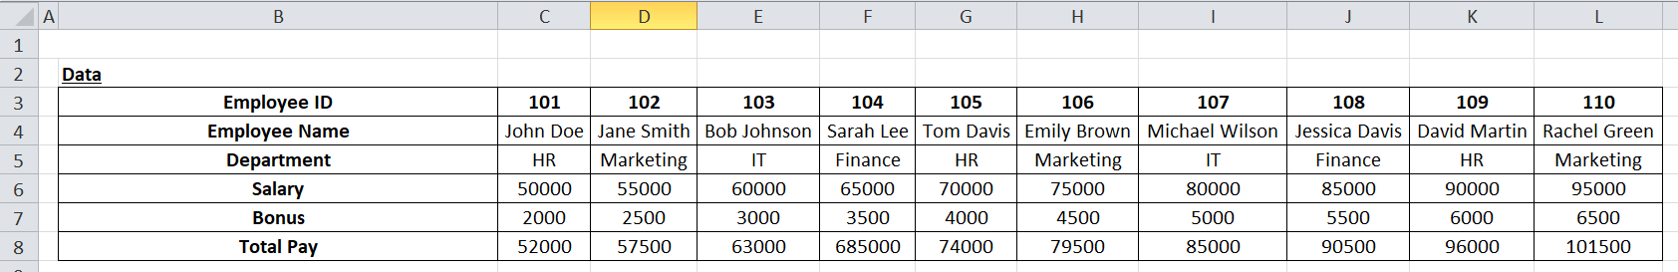

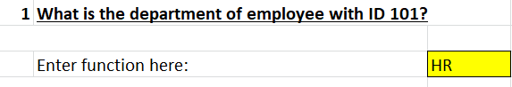
FORMULA: =HLOOKUP(C3,B3:L8,3,FALSE)
Explanation:
The HLOOKUP formula is used to search for a value in the top row of a table and return in the same column
from a specified row.
The first argument, 102, is the value we want to look up.
The second argument, C3:M8, is the range of cells that contain the data we want to look in.
The third argument, 3, is the row number that contains the information we want to retrieve.
The fourth argument, FALSE, indicates that the match must be exact.
This formula returns the department of employee with ID 102,

which is Marketing.

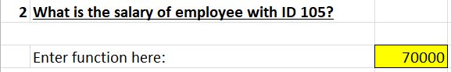
FORMULA: =HLOOKUP(G3,B3:L8,4,FALSE)

Explanation:
The HLOOKUP formula is used to search for a value in the top row of a table and return a specified row.
The first argument, 105, is the value we want to look up. The second argument, B3:L8, i contain the data we want to look in.
The third argument, 4, is the row number that contains the information we want to retrie The fourth argument indicates that the
match must be exact.
This formula returns the salary of employee with ID 105, which is 70000.

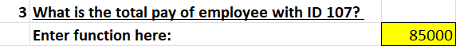
FORMULA: =HLOOKUP(I3,B3:L8,6,FALSE)
Explanation:
The HLOOKUP formula is used to search for a value in the top row of a table and return same column from
a specified row.
The first argument, 107, is the value we want to look up. The second argument, B3:L8, i cells that contain
the data we want to look in.
The third argument, 6, is the row number that contains the information we want to retrieve.
The fourth argument, FALSE, indicates that the match must be exact.
This formula returns the total pay of employee with ID 107, which is 85000.

PRACTICE QUESTIONS
John
Andy
John
Peter
Bret
John
Eli
Micheal
Tiger
Micheal
Tony
Prince
Brad
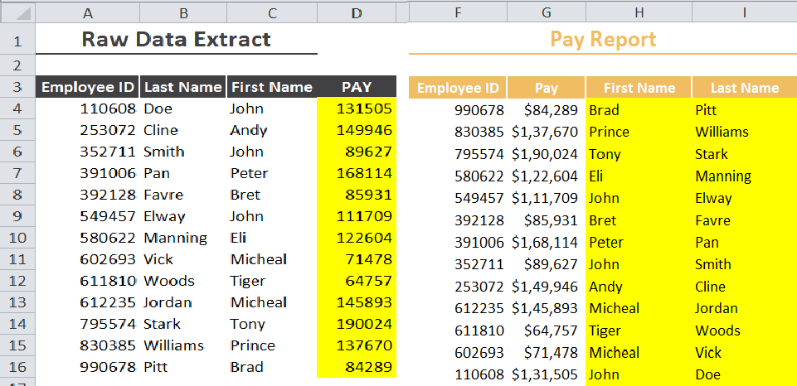
QUESTION 1

FORMULA FOR

PAY (cell D4)- =VLOOKUP(A4,$F$4:$I$16,2,FALSE)
FIRST NAME (cell H4)- =VLOOKUP(F4,$A$4:$C$16,3,FALSE)
LAST NAME (cell I4)- =VLOOKUP(F4,$A$4:$C$16,2,FALSE)
200000
180000
160000
140000
120000
100000
80000
60000
40000
20000
0
PAY
DoeCline SmithPanFavre Elway Manning Vick Woods Jordan Stark Williams Pitt
110608253072352711391006392128549457580622602693611810612235795574830385990678

QUESTION 2
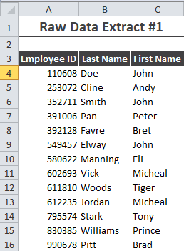
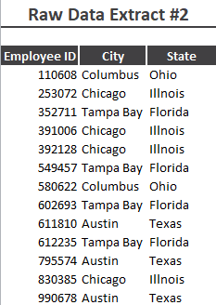
ANSWER:
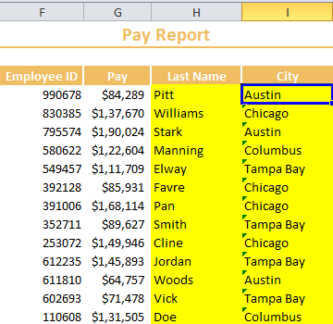

FORMULA FOR
LAST NAME (CELL H4): =VLOOKUP(F4,$A$4:$C$16,2,FALSE)
Page15
CITY (CELL I4): =VLOOKUP(F4:F16,$A$24:$B$36,2,FALSE)
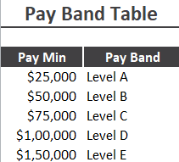
QUESTION 3

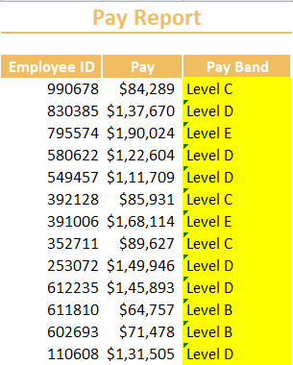
ANSWER:

FORMULA FOR PAY BAND:
=VLOOKUP(F4:F16,$A$4:$B$8,2,TRUE)

Index Matching Function
The INDEX MATCH Formula is the combination of two functions in Excel: INDEX and MATCH.
=INDEX() returns the value of a cell in a table based on the column and row number.
=MATCH() returns the position of a cell in a row or column.
Combined, the two formulas can look up and return the value of a cell in a table based on vertical and horizontal criteria. For short, this is referred to as just the Index Match function.

How to Use the INDEX Formula
Below is a table showing people’s names, height, and weight. We want to use the INDEX formula to look up Kevin’s height… here is an example of how to do it.
Follow these steps:
- Type “=INDEX(” and select the area of the table, then add a comma
- Type the row number for Kevin, which is “4,” and add a comma
- Type the column number for Height, which is “2,” and close the bracket
- The result is “5.8.”

How to Use the MATCH Formula
- Type “=MATCH(” and link to the cell containing “Kevin”… the name we want to look up.
- Select all the cells in the Name column (including the “Name” header).
- Type zero “0” for an exact match.

How to Combine INDEX and MATCH
Follow these steps:
- Cut the MATCH formula for Kevin and replace the “4” with it.
- Cut the MATCH formula for Height and replace the “2” with it.
- The result is Kevin’s Height is “5.8.”
- Congratulations, you now have a dynamic INDEX MATCH formula!

Calculate the Index by using Index Matching Function
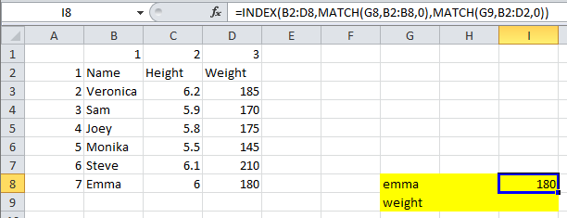
FORMULA: =INDEX(B2:D8,MATCH(G8,B2:B8,0),MATCH(G9,B2:D2,0))

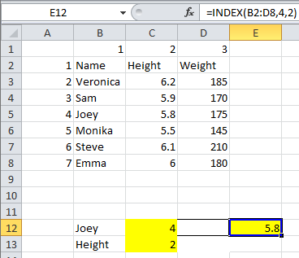
FORMULA: =INDEX(B2:D8,4,2)

Net Present Value (NPV)
Calculates the net present value of an investment by using a discount rate and a series of future payments (negative values) and income (positive values). Calculates the net present value of an investment by using a discount rate and a series of future payments (negative values) and income (positive values).
Syntax
NPV(rate,value1,[value2],...)
The NPV function syntax has the following arguments:
- Rate Required. The rate of discount over the length of one period.
- Value1, value2, ... Value1 is required, subsequent values are optional. 1 to 254 arguments representing the payments and income.
- Value1, value2, ... must be equally spaced in time and occur at the end of each period.
- NPV uses the order of value1, value2, ... to interpret the order of cash flows. Be sure to enter your payment and income values in the correct sequence.
- Arguments that are empty cells, logical values, or text representations of numbers, error values, or text that cannot be translated into numbers are ignored.
- If an argument is an array or reference, only numbers in that array or reference are counted. Empty cells, logical values, text, or error values in the array or reference are ignored.
Remarks
The NPV investment begins one period before the date of the value1 cash flow and ends with the last cash flow in the list. The NPV calculation is based on future cash flows. If your first cash flow occurs at the beginning of the first period, the first value must be added to the NPV result, not included in the values arguments. For more information, see the examples below.
If n is the number of cash flows in the list of values, the formula for NPV is:

Equation
NPV is similar to the PV function (present value). The primary difference between PV and NPV is that PV allows cash flows to begin either at the end or at the beginning of the period. Unlike the variable NPV cash flow values, PV cash flows must be constant throughout the investment. For information about annuities and financial functions, see PV.

NPV is also related to the IRR function (internal rate of return). IRR is the rate for which NPV equals zero: NPV(IRR(...), ...) = 0.
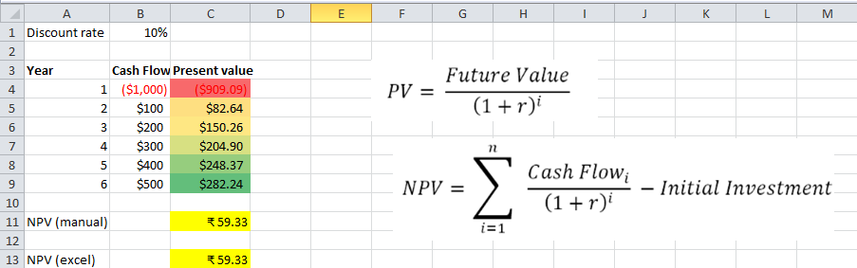

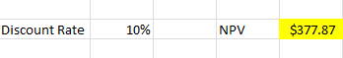
Question 1

FORMULA FOR NPV: =NPV(B9,B2,C2,D2,E2,F2,G2,H2,I2,J2,K2)

Question 2

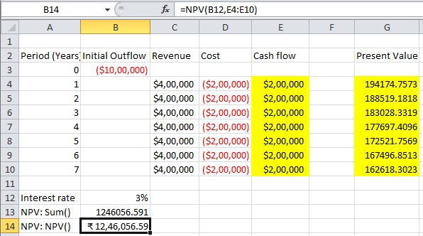
FORMULA: =NPV(B12,E4:E10)

IF lookup Function
The Excel IF Statement tests a given condition and returns one value for a TRUE result and another value for a FALSE result. For example, if sales total more than
$5,000, then return a “Yes” for Bonus; otherwise, return a “No” for Bonus. We can also use the IF function to evaluate a single function, or we can include several IF functions in one formula. Multiple IF statements in Excel are known as nested IF statements.
IF Formula
=IF(logical_test, value_if_true, value_if_false)
=IF(logical_test, value_if_true, value_if_false)
The function uses the following arguments:
- Logical_test (required argument) – This is the condition to be tested and evaluated as either TRUE or FALSE.
- Value_if_true (optional argument) – The value that will be returned if the logical_test evaluates to TRUE.
- Value_if_false (optional argument) – The value that will be returned if the logical_test evaluates to FALSE.
When using the IF function to construct a test, we can use the following logical operators:
• = (equal to)
  - > (greater than)
  - >= (greater than or equal to)
  - < (less than)
  - <= (less than or equal to)
  - <> (not equal to)
Vlookup with If statement: return True/False, Yes/No, etc.
One of the most common scenarios when you combine If and Vlookup together is to compare the value returned by Vlookup with a sample value and return Yes / No or True / False as the result.
In most cases, the following generic formula would work nicely:
IF(VLOOKUP(…) = value, TRUE, FALSE)
Translated in plain English, the formula instructs Excel to return True if Vlookup is true (i.e. equal to the specified value). If Vlookup is false (not equal to the specified value), the formula returns False.

QUESTIONS
- What will the result be if the value A1:D5 is greater than 92? By Using IF Function.

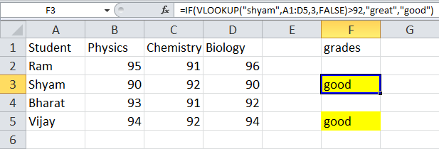

FORMULA: =IF(VLOOKUP("shyam",A1:D5,3,FALSE)>92,"great","good")
- If the value of column A from A2 to A6 is greater than 180, what percentage of that value will be used, and if not, what percentage of that value will be used?"
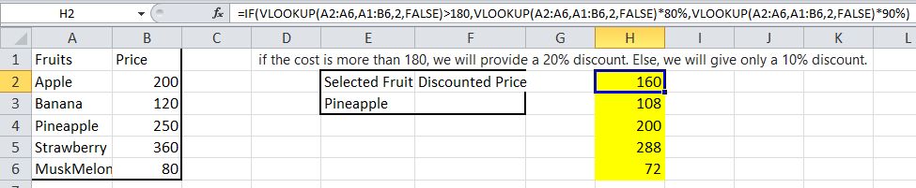
FORMULA:
=IF(VLOOKUP(A2:A6,A1:B6,2,FALSE)>180,VLOOKUP(A2:A6,A1:B6,2, FALSE)*80%,VLOOKUP(A2:A6,A1:B6,2,FALSE)*90%)

IRR FUNCTION
The IRR Function is categorized under Excel Financial functions. IRR will return the Internal Rate of Return for a given cash flow, that is, the initial investment value and a series of net income values.
The function is very helpful in financial modeling, as it helps calculate the rate of return an investment would earn based on a series of cash flows. It is frequently used by businesses to compare and decide between capital projects.
One example is when a company is presented with two opportunities: one is investing in a new factory, and the second is expanding its existing factory. Using the IRR function, we can estimate the IRRs for both scenarios and check which one is higher than the weighted average cost of capital (WACC) of the business (also known as a hurdle rate ). If both are greater than the cost of capital, we will choose the one that shows a higher IRR and/or Net Present Value (NPV) than the other.

IRR Formula
=IRR(values,[guess])
The IRR function uses the following arguments:
- Values (required argument) – This is an array of values that represent the series of cash flows. Cash flows include investment and net income values. Values can be a reference to a range of cells containing values.
- [Guess] (optional argument) – This is a number guessed by the user that is close to the expected internal rate of return (as there can be two solutions for the internal rate of return). If omitted, the function will take a default value of
0.1 (=10%).
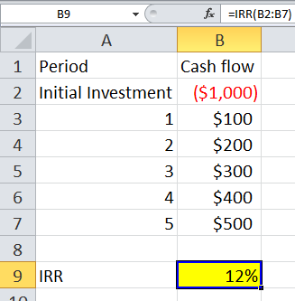
Q.Find the Internal Rate of Return using IRR Function?
IRR FUNCTION: =IRR(B2:B7)

XIRR FUNCTION
The XIRR Function is categorized under Excel financial functions. It will calculate the Internal Rate of Return (IRR) for a series of cash flows that may not be periodic. It does this by assigning specific dates to each individual cash flow. The main benefit of using the XIRR Excel function is that such unevenly timed cash flows can be accurately modeled. To learn more, read why to always use XIRR over
IRR in Excel modeling.
In financial modeling, the XIRR function is useful in determining the value of an investment or understanding the feasibility of a project that does not have regularly periodic cash flows. It helps us understand the rate of return earned on an investment. Hence, it is commonly used in evaluating and choosing between two or more investments.

Formula
=XIRR(values, dates,[guess])
The formula uses the following arguments:
- Values (required argument) – This is the array of values that represent the series of cash flows. Instead of an array, it can be a reference to a range of cells containing values.
- Dates (required argument) – This is a series of dates that correspond to the given values. Subsequent dates should be later than the first date, as the first date is the start date and subsequent dates are future dates of outgoing payments or income.
- [guess] (optional argument) – This is an initial guess – or estimate – of what the IRR will be. If omitted, Excel takes the default value of 10%.
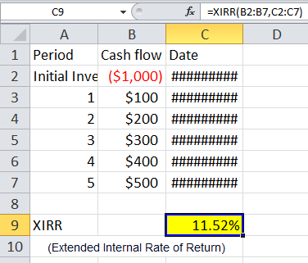
Q.Find the Extended Internal Rate of Return using the formula?
XIRR FUNCTION: =XIRR(B2:B7,C2:C7)

MIRR FUNCTION
The modified internal rate of return (MIRR) assumes that positive cash flows are reinvested at the firm's cost of capital and that the initial outlays are financed at the firm's financing cost. By contrast, the traditional internal rate of return (IRR) assumes the cash flows from a project are reinvested at the IRR itself. The MIRR, therefore, more accurately reflects the cost and profitability of a project.
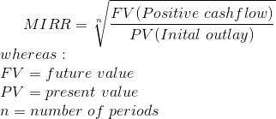

Limitations of Using MIRR
The first limitation of MIRR is that it requires you to compute an estimate of the cost of capital in order to make a decision, a calculation that can be subjective and vary depending on the assumptions made.8
As with IRR, the MIRR can provide information that leads to sub-optimal decisions that do not maximize value when several investment options are being considered at once. MIRR does not actually quantify the various impacts of different investments in absolute terms; NPV often provides a more effective theoretical basis for selecting investments that are mutually exclusive. It may also fail to produce optimal results in the case of capital rationing.

Q. Find modified internal rate of return using formula.
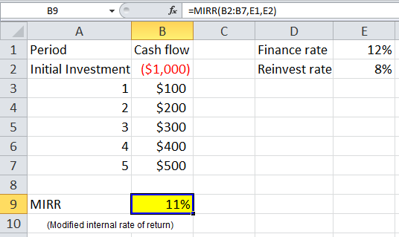
MIRR FORMULA: =MIRR(B2:B7,E1,E2)

WACC FUNCTION
The weighted average cost of capital (WACC) is a financial metric that shows what the total cost of capital is for a firm.1 Rather than being dictated by a company's management, WACC is determined by external market participants and signals the minimum return that a corporation would take in on an existing asset base. Companies that don't demonstrate an inviting WACC number may lose their funding sources who are likely to deploy their capital elsewhere.

WACC Formula
WACC is calculated with the following equation:

WACC: (% Proportion of Equity * Cost of Equity) + (% Proportion of Debt * Cost of Debt * (1 - Tax Rate))
The proportion of equity and proportion of debt are found by dividing the total assets of a company by each respective account. Since all assets are financed via equity or debt, total equity plus total liabilities should equal 100%. This assumes any operating liabilities like accounts payable are excluded.
As the company incurs more debt, the rate charged by the lender will likely increase as the company's risk profile will also increase. There is a tax shield impact of interest charged on debt, therefore the cost of debt is reduced by potential tax benefits.

Calculating WACC in Excel

Calculating WACC is a relatively straight forward exercise. As with most financial modeling, the most challenging aspect is obtaining the correct data with which to plug into the model.
- Obtain appropriate financial information of the company you want to calculate the WACC for. You will need the company's balance sheet, and you need to transfer the company's equity and the company's debt into Excel. You will also need public share information as well as prior year annual report information.
- Determine the debt-to-equity proportion. Divide each category by the sum of the two categories. To find the equity proportion, divide the total equity by the sum of total equity and total debt. Alternatively, divide total debt by the sum of total equity and total debt to find the debt proportion.
- Determine the cost of equity. The cost of equity is found by dividing the company's dividends per share by the current market value of stock. Then, if applicable, add the growth rate of dividends.

- Multiply the equity proportion (Step 2) by the cost of equity (Step 3). This it the company's proportional cost of equity.
- Determine the cost of debt. This is the prevailing interest rate required by lenders in exchange for issuing loans. The interest rate will vary from company to company due to varying levels of risk.
- Determine the company's tax rate. This can be estimated by looking at prior- year annual reports or identifying the most current tax tables for companies.
- Multiply the proportion of debt (Step 2) by the cost of debt (Step 5). Then, multiply this product by (1 - tax rate). This is the company's proportional cost of debt.
- Add Step 4 and Step 7. This is the company-wide weighted cost of capital.

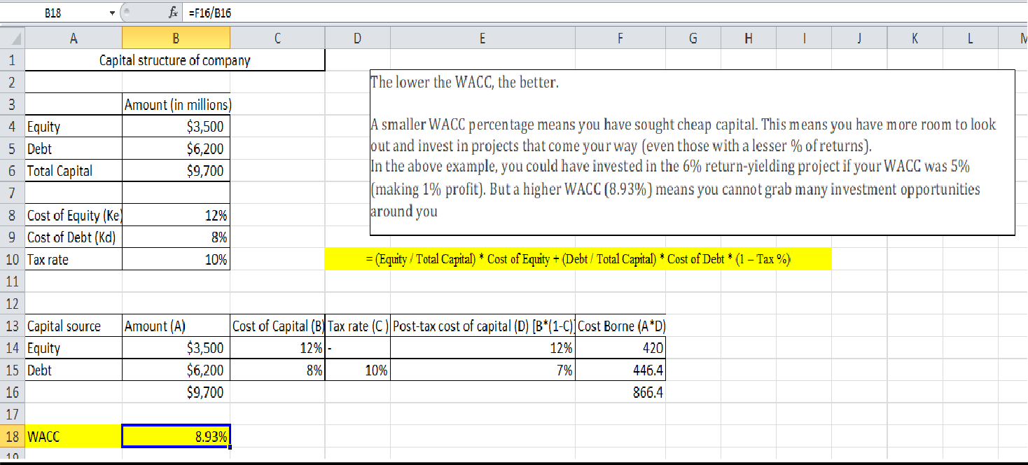
Q. Find the WACC(weighted average cost of capital) by using formula.
FORMULA: =F16/B16

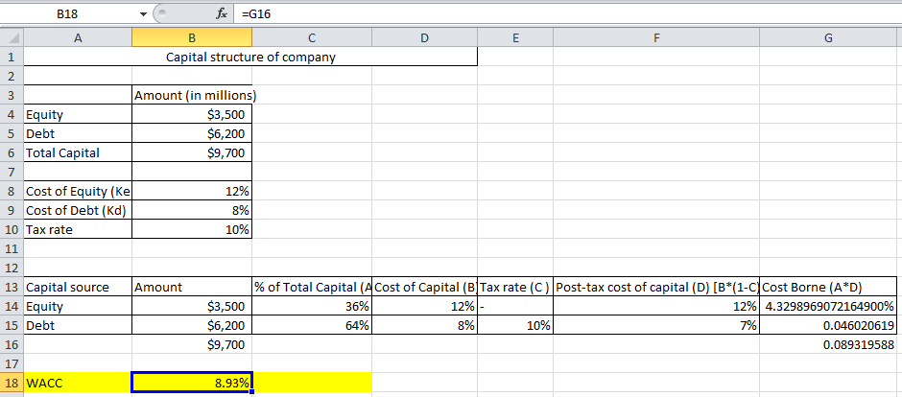
FORMULA: =G16

Capital Asset Pricing Model (CAPM)
The capital asset pricing model (CAPM) is a component of the efficient market hypothesis and modern portfolio theory. CAPM measures the amount of an asset's expected return which is the first step in building out an efficient frontier. CAPM itself uses a foundational equation to calculate the expected return of an asset (usually a stock) with the incorporation of several factors.
The formula for calculating the expected return of an asset using the capital asset pricing model is as follows:
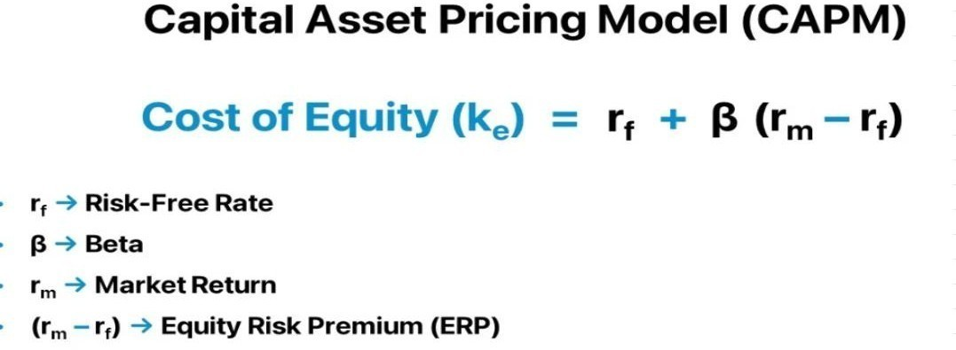

As shown from the above equation, CAPM involves the risk-free rate, an asset’s beta, and the expected return of the market. It can be important to ensure that these values are all taken from the same time period. Here we use a 10-year time period.
To calculate an asset's expected return, start with a risk-free rate (the yield on the 10- year Treasury) then add an adjusted premium. The adjusted premium added to the risk-free rate is the difference in the expected market return times the beta of the asset.
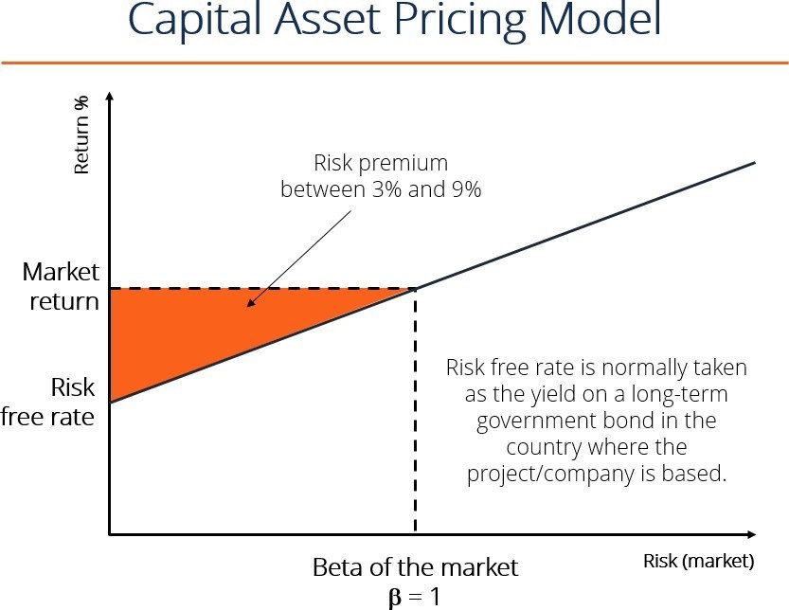

Q. Find the Capital Asset Pricing Model using formula?
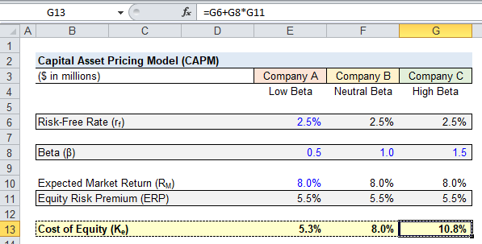
FUNCTION: =G6+G8*G11

Beta
Beta (β) is a measure of the volatility—or systematic risk—of a security or portfolio compared to the market as a whole (usually the S&P 500). Stocks with betas higher than 1.0 can be interpreted as more volatile than the S&P 500.
Beta is used in the capital asset pricing model (CAPM), which describes the relationship between systematic risk and expected return for assets (usually stocks). CAPM is widely used as a method for pricing risky securities and for generating estimates of the expected returns of assets, considering both the risk of those assets and the cost of capital.

How Beta Works
A beta coefficient can measure the volatility of an individual stock compared to the systematic risk of the entire market. In statistical terms, beta represents the slope of the line through a regression of data points. In finance, each of these data points represents an individual stock's returns against those of the market as a whole.

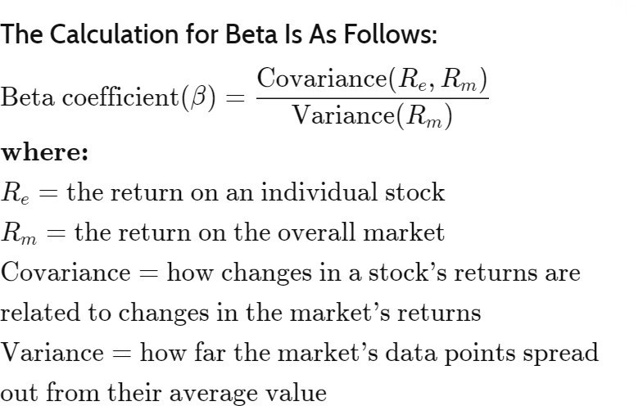
The Calculation for Beta Is As Follows:

CAPM and Beta
The beta of a potential investment is a measure of how much risk the investment will add to a portfolio that looks like the market. If a stock is riskier than the market, it will have a beta greater than one. If a stock has a beta of less than one, the formula assumes it will reduce the risk of a portfolio.
A stock’s beta is then multiplied by the market risk premium, which is the return expected from the market above the risk-free rate. The risk-free rate is then added to the product of the stock’s beta and the market risk premium.
The result should give an investor the required return or discount rate that they can use to find the value of an asset.
Q. Find the Beta value in CAPM using Formula?
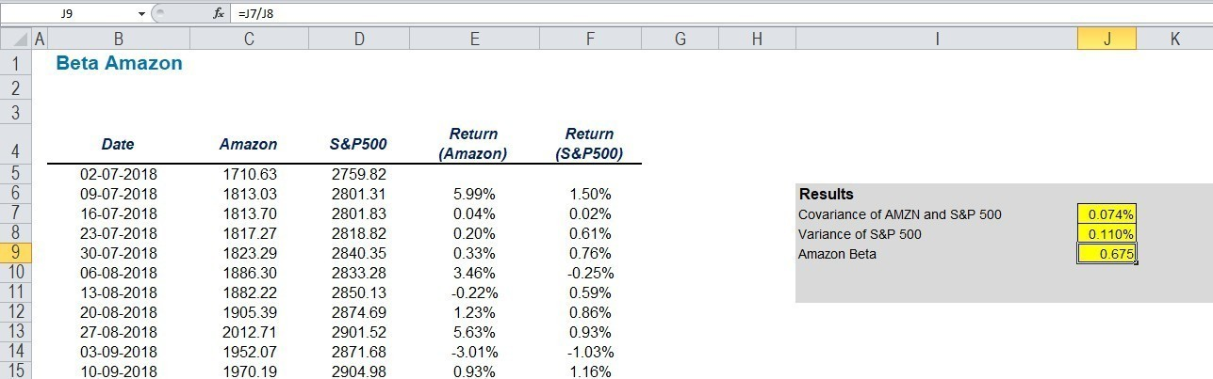
FORMULA: =J7/J8

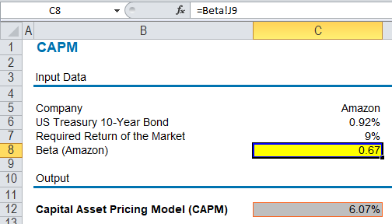
FORMULA: =Beta!J9

CONCLUSION

Financial modeling using spreadsheets is an indispensable tool for businesses and financial professionals alike. It enables them to analyze, forecast, and make informed decisions based on quantitative data. By structuring financial information in a systematic and organized manner, spreadsheets facilitate the evaluation of various scenarios, sensitivity analyses, and risk assessments.
Additionally, they provide a platform for stakeholders to understand the financial implications of different strategies and investment opportunities. Despite the advancements in specialized financial software, spreadsheets remain a preferred choice due to their flexibility, accessibility, and user-friendly interface. However, it's essential to ensure accuracy and reliability by implementing robust formulas, proper data validation, and regular updates. In conclusion, financial modeling through spreadsheets empowers organizations to navigate complex financial landscapes, optimize performance, and drive sustainable growth.

